PAT Design

George Marais



**InfoSave**

Contents

**User Interface Design** 3

**Login** 3

Login screen 12

Sign Up screen 13

Main screen 14

Help screen 16

tableModel 17

signupForm 18

functions 19

helpLogin 19

helpSignUp 20

infoQuery 20

info 21

InfoSave 22

myConnection 23

loginForm 24

Primary 27

functions class 27

loginForm class 27

signupForm class 27

InfoSave class 27

helpLogin class 27

helpSignUp class 27

infoQuery class 27

info class 27

myConnection class 27

tableModel class 27

Secondary 28

SignUp 28

Info 28

# **User Interface Design**

## **Login**

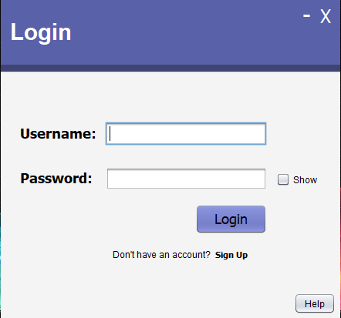

|  |  |
| --- | --- |
| Description | The login screen will display a login button, a Username and Password text box with a show password checkbox, a clickable Sign Up text that will take users to the signup page to create a new account and a help button to take you to the login help screen. |
| Data | A Close window label (X), Minimize window label (-), Login button, Clickable Sign Up label, Username and Password text box, Show password checkbox, Help button |
| Actions | **Close**   * A Close window label (X) will when clicked, close the current window.   **Minimize**   * A Minimize window label (-) will when clicked, minimize the current window.   **Login**   * The login button will check if the username and password entered into their corresponding fields have already been stored in the database. If the details are incorrect an error message will show saying “Username or Password incorrect” otherwise it will take you to your account window.   **Show Password**   * A show password checkbox can be used to show the password that the user inputted into the password text field.   **Sign Up**   * Directs the user to the Sign-up form.   **Help**   * Takes the user to the login help screen. |

**Sign Up screen**

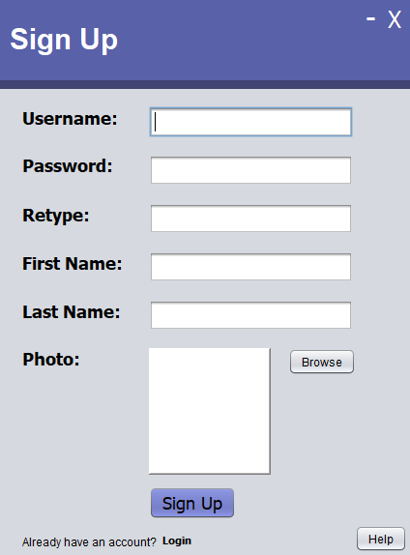

|  |  |
| --- | --- |
| Description | The sign-up screen will display a sign-up button, a Username, Password, retype password, First Name and Last Name text box and a Photo label, a clickable login text that will take users to the login page to login and a help button to take you to the sign up help screen. |
| Data | A Close window label (X), Minimize window label (-), Sign Up button, Clickable login label, Username, Password, retype password, First Name and Last Name text box and a Photo label, Help button |
| Actions | **Close**   * A Close window label (X) will when clicked, close the current window.   **Minimize**   * A Minimize window label (-) will when clicked, minimize the current window.   **Sign Up**   * The sign-up button will check the Username, Password, retype password, First Name and Last Name text box and a Photo label for values that can be used to create an account. If there is a problem with the information you inputted, a message will pop up informing you of the problem.   **Login**   * Directs the user to the login form.   **Help**   * Takes the user to the login help screen. |

**Main screen**

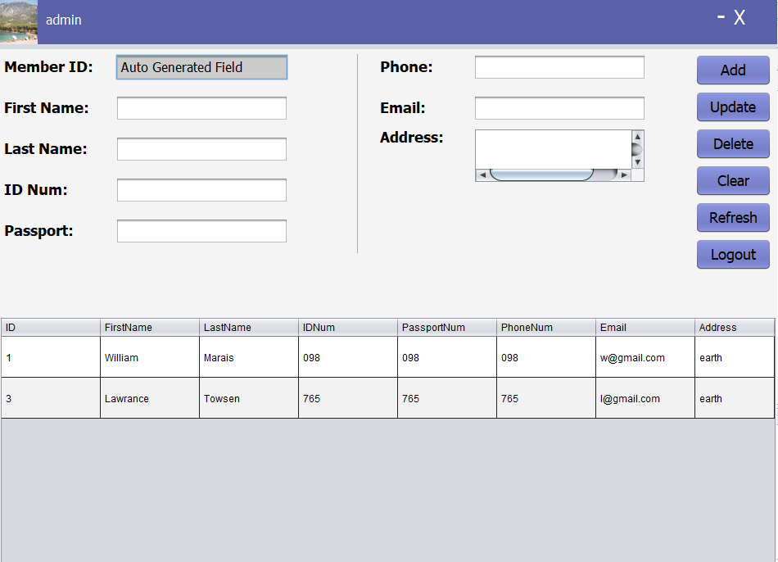

|  |  |
| --- | --- |
| Description | Once the user has logged in, they will be taken to the main screen where they can add members to their account by inputting the required information into the fields. They can delete or update member information. The members information for that account from the database will be displayed in a table. |
| Data | A Close window label (X), Minimize window label (-), Add button, Update button, Delete button, Clear button, Refresh button and a Logout button, Member ID, First Name, Last Name, ID Number, Passport Number, Phone Number, Email and Address text fields, Profile picture label and username label. |
| Actions | **Close**   * A Close window label (X) will when clicked, close the current window.   **Minimize**   * A Minimize window label (-) will when clicked, minimize the current window.   **Add**   * The Add button will check the First Name, Last Name, ID Number, Passport Number, Phone Number, Email and Address text fields for values that can be used to create a member and will then insert that information into a table.   **Update**   * The Update button will check the First Name, Last Name, ID Number, Passport Number, Phone Number, Email and Address text fields for values that can be used to update a member’s information and will then update that member’s information in the table.   **Delete**   * The Delete button will check the Member ID text field for the ID value that can be used to delete a member’s information from the table the table.   **Clear**   * The Clear button will set the values of all the text fields to blank so that the user can input new information.   **Refresh**   * The Refresh button will set the values in the table to the newly updated values from the database.   **Logout**   * The Logout button will take the user back to the login screen. |

**Login Help screen**

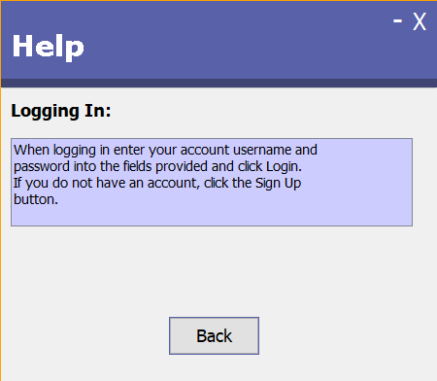

|  |  |
| --- | --- |
| Description | The help screen will have a text area where how to login is explained. It also has a back button to take the user back to the login screen. |
| Data | How to Login |
| Actions | **Close**   * A Close window label (X) will when clicked, close the current window.   **Minimize**   * A Minimize window label (-) will when clicked, minimize the current window.   **How To Login**   * Explains to the user how to login.   **Back**   * Takes the user back to the login screen. |

**Sign Up Help screen**

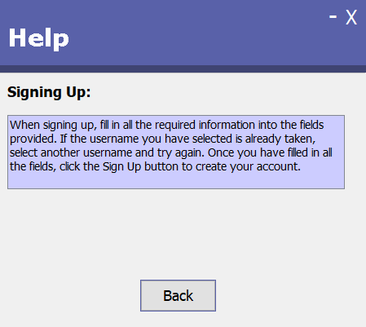

|  |  |
| --- | --- |
| Description | The help screen will have a text area where how to sign up is explained. It also has a back button to take the user back to the sign-up screen. |
| Data | How to Sign Up |
| Actions | **Close**   * A Close window label (X) will when clicked, close the current window.   **Minimize**   * A Minimize window label (-) will when clicked, minimize the current window.   **How To Sign Up**   * Explains to the user how to sign up.   **Back**   * Takes the user back to the sign-up screen. |

**Sequencing and Algorithms**

The screens will flow from the Login screen, to the main screen, sign up screen, or help screen. The Help menu can be accessed from the login screen and the sign-up screen.

## Login screen

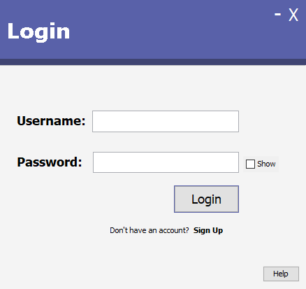

* This SQL statement ***ps = con.prepareStatement("SELECT UserName, Password, Photo, ID FROM SignUp WHERE Username = ? AND Password = ?");***

***ps.setString(1,Username.getText());***

***ps.setString(2,String.valueOf(Password.getPassword()));*** will be called once the login button is pushed.

* Sign Up: If clicked will take you to the sign-up screen.
* Help button: display helpLogin.
* Once the user has clicked on Login the main screen will open.

## 

## Sign Up screen

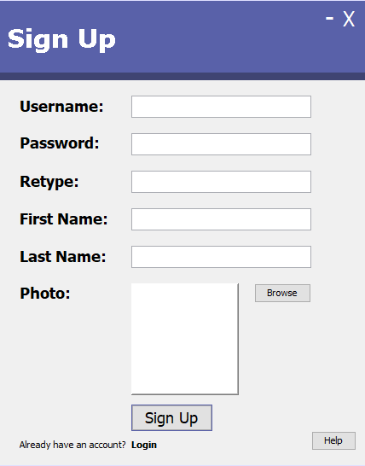

* This SQL statement ***ps = con.prepareStatement("INSERT INTO SignUp(Username, Password, FirstName, LastName, Photo) VALUES(?, ?, ?, ?, ?)");***

***ps.setString(1,Username.getText());***

***ps.setString(2,String.valueOf(Password.getPassword()));***

***ps.setString(3,FirstName.getText());***

***ps.setString(4,LastName.getText());***

***InputStream img = new FileInputStream(new File(imagePath));***

***ps.setBlob(5, img);*** will be called once the sign-up button is pushed.

* Login: If clicked will take you to the login screen.
* Help button: display helpSignUp.
* Once the user has clicked on Sign Up, the login screen will open.

## Main screen



* Instantiates the members of the account and inputs them into the table:

**infoQuery iq = new infoQuery();**

**ArrayList<info> iList = iq.infoList(currentUserID);**

**String[] colNames = {"ID","FirstName","LastName","IDNum","PassportNum","PhoneNum","Email","Address"} ;**

**Object[][] rows = new Object[iList.size()][8];**

* The Add inserts new members into the table in the database:

**info i = new info(0,FirstName,LastName,IDNum,PassportNum,PhoneNum,Email,Address,CID);**

**infoQuery iq = new infoQuery();**

**iq.insert(i);**

* The Update updates the record in the database table with the changed record:

**info i = new info(ID,FirstName,LastName,IDNum,PassportNum,PhoneNum,Email,Address,0);**

**infoQuery iq = new infoQuery();**

**iq.update(i);**

* The Delete removes a record from the database table based on the current Member ID selected and then sets all the text fields to blank:

**int ID = Integer.valueOf(txtID.getText());**

**infoQuery iq = new infoQuery();**

**iq.delete(ID);**

**txtFirstName.setText("");**

**txtLastName.setText("");**

**txtIDNum.setText("");**

**txtPassportNum.setText("");**

**txtPhoneNum.setText("");**

**txtEmail.setText("");**

**txtAddress.setText("");**

**txtID.setText("");**

* The Clear sets all the text field values to blank:

**txtFirstName.setText("");**

**txtLastName.setText("");**

**txtIDNum.setText("");**

**txtPassportNum.setText("");**

**txtPhoneNum.setText("");**

**txtEmail.setText("");**

**txtAddress.setText("");**

**txtID.setText("");**

* The Refresh reimports the values from the database table into the table to show updated members:

**inputTable();**

* The Logout takes you back to the login screen:

**loginForm lf = new loginForm();**

**lf.setVisible(true);**

**lf.pack();**

**lf.setLocationRelativeTo(null);**

**lf.setDefaultCloseOperation(JFrame.EXIT_ON_CLOSE);**

**this.dispose();**

## Help screen



* The login or sign up help screen will be brought up whenever the help button is pushed.
* The back button takes the user back to the screen they clicked the help button in (i.e. the login or sign up screens):

For Login Help screen:

**loginForm lf = new loginForm();**

**lf.setVisible(true);**

**lf.pack();**

**lf.setLocationRelativeTo(null);**

**lf.setDefaultCloseOperation(JFrame.EXIT_ON_CLOSE);**

**this.dispose();**

For Sign Up Help screen:

**signupForm sf = new signupForm();**

**sf.setVisible(true);**

**sf.pack();**

**sf.setLocationRelativeTo(null);**

**sf.setDefaultCloseOperation(JFrame.EXIT_ON_CLOSE);**

**this.dispose();**

**Class Diagrams**

## tableModel

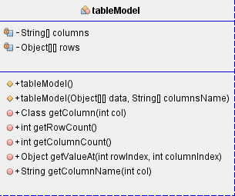

## signupForm

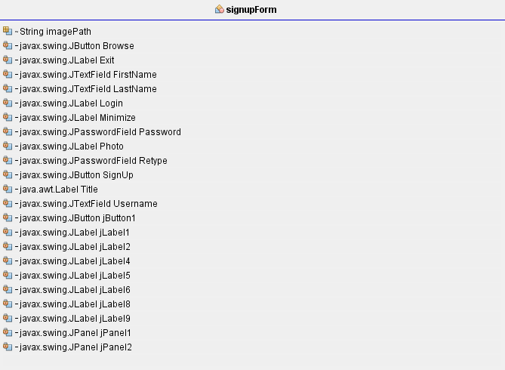

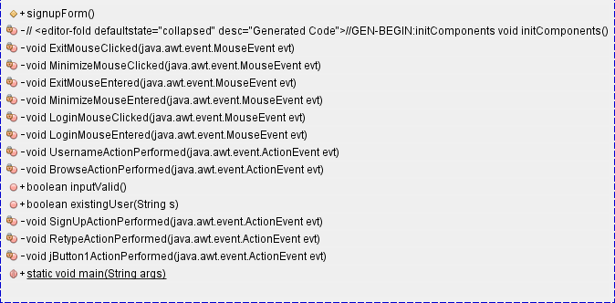

## functions

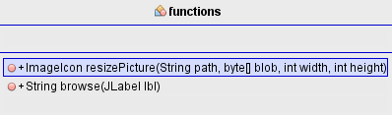

## helpLogin

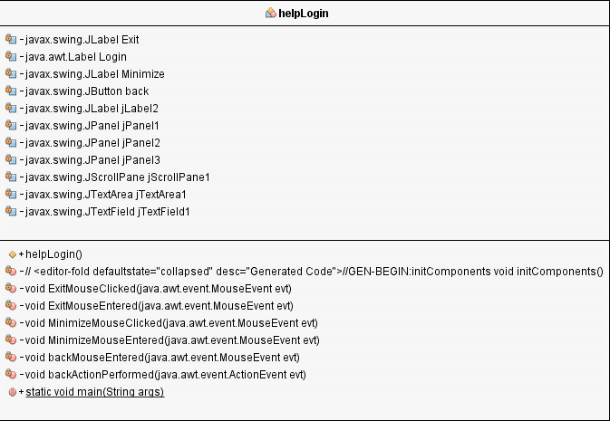

## helpSignUp

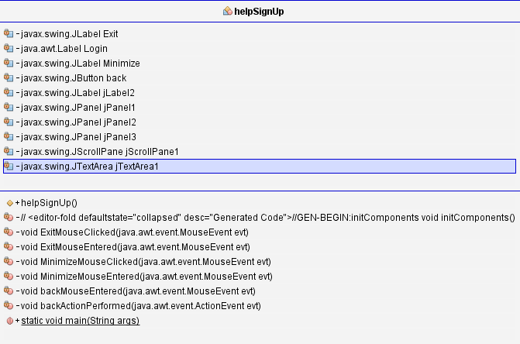

## infoQuery

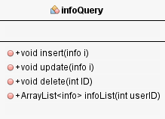

## info

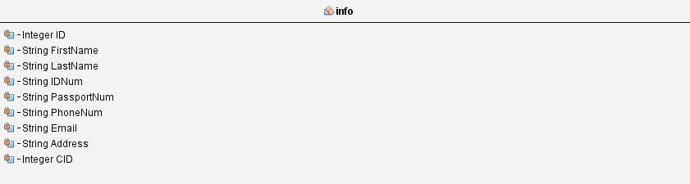

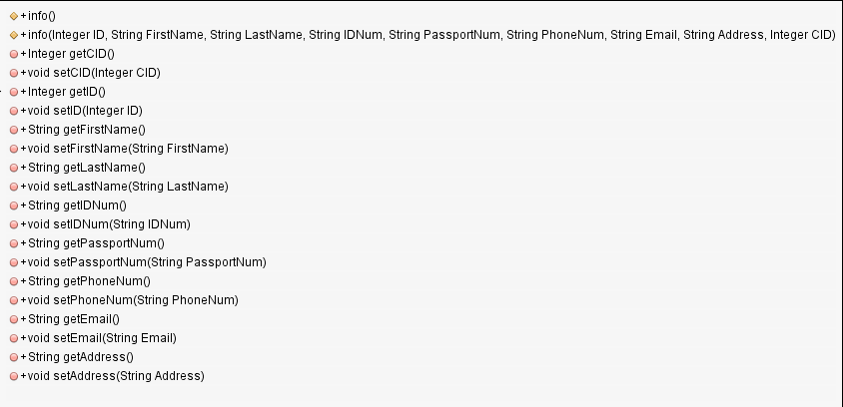

## InfoSave

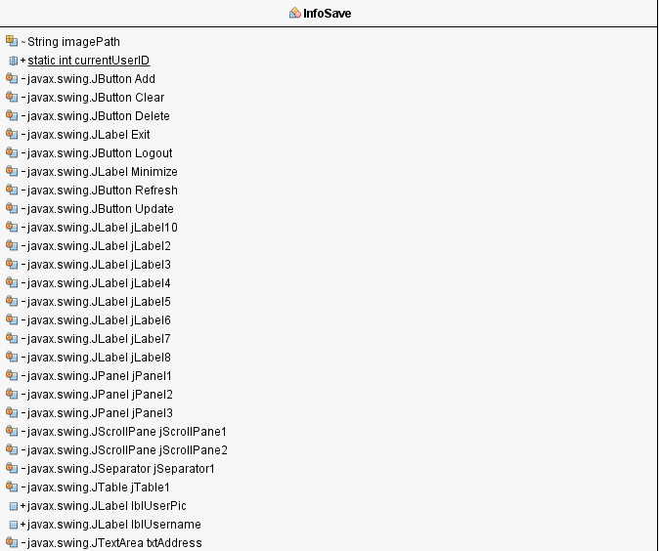

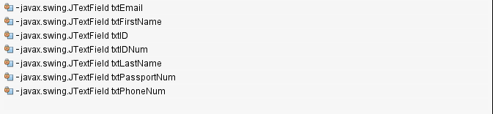

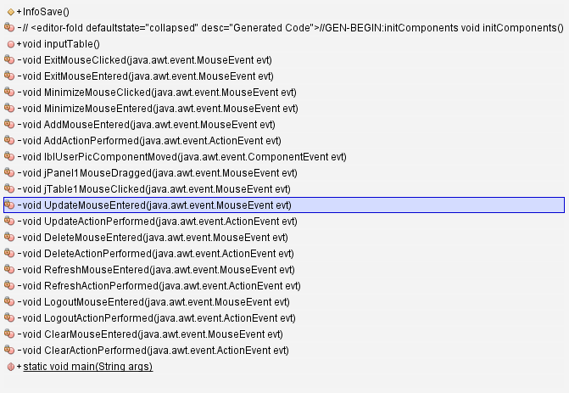

## myConnection

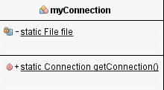

## loginForm

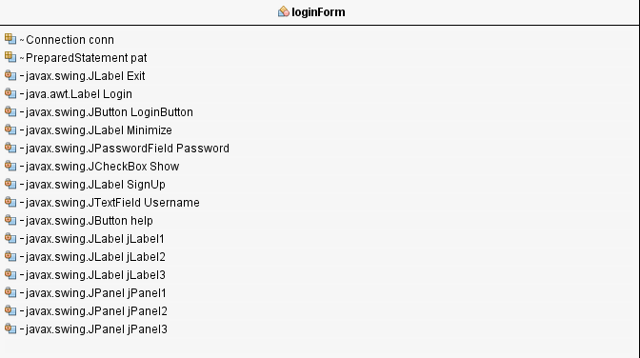

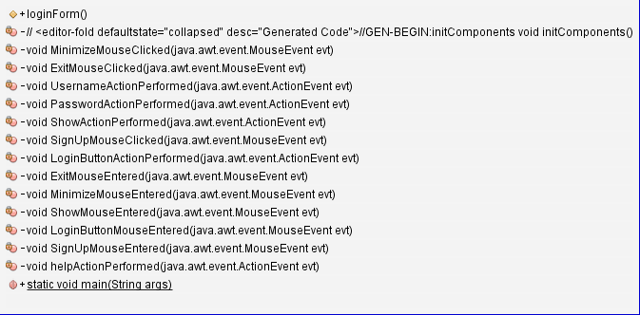

**Persistent Storage Design**

Tables are provided for the user’s account details and for the members of their accounts.

* The user’s details are stored in a table in a database (SignUp)
* The member’s information is stored in a table in a database (Info)

SignUp



|  |  |  |  |
| --- | --- | --- | --- |
| **Field** | **Type** | **Description** | **Example** |
| ID | Auto Number | Auto number | 1 |
| Username | Short Text | Selected username by user | admin |
| Password | Short Text | Selected password by user | admin |
| FirstName | Short Text | User’s first name | George |
| LastName | Short Text | User’s last name | Marais |
| Photo | OLE Object | Selected profile photo by the user | Img.jpg |

Info



|  |  |  |  |
| --- | --- | --- | --- |
| **Field** | **Type** | **Description** | **Example** |
| ID | Auto Number | Auto number | 1 |
| FistName | Short Text | Member name | George |
| LastName | Short Text | Member last name | Marais |
| IDNum | Short Text | Member ID number | 09566768686 |
| PassportNum | Short Text | Member passport number | 029747474 |
| PhoneNum | Short Text | Member phone number | 09374856 |
| Email | Short Text | Member member email address | g@gmail.com |
| Address | Short Text | Member address | 1 Elbow Street |
| CID | Integer | Current User ID of the account of the user creating the member record | 2 |

**Explanation of Storage Design**

## Primary

The classes are stored in primary storage.

### functions class

This class creates a resize picture and browse which are both instantiated every time the program is run.

### loginForm class

This creates the login screen which is not permanently stored.

### signupForm class

This creates the sign-up screen which is not permanently stored.

### InfoSave class

This creates the InfoSave screen which is not permanently stored.

### helpLogin class

This creates the help login screen which is not permanently stored.

### helpSignUp class

This creates the help sign-up screen which is not permanently stored.

### infoQuery class

This creates an array to store the information of the different inputted values and instantiates the insert, delete and update classes which are not permanently stored.

### info class

Is used to construct and assign values to different variables.

### myConnection class

Creates a connection to the database when the program starts.

### tableModel class

Creates a custom table to display the member information.

## Secondary

The tables are stored in secondary storage. The tables store the permanent information such as the User’s password, username and photo.

### SignUp

SignUp stores the username, password, first name, last name and profile photo of each user. SignUp receives information from the Login screen.

### Info

Info stores the information of each member that has been added to any account. Info receives information from the main screen.